SpecterX Outlook New Connector for Microsoft 365
The SpecterX Outlook Connector for Microsoft 365 enables users to apply file-level protection and automated governance to sensitive information shared through email without leaving their existing Outlook workflow. By integrating directly into the Outlook compose experience, the connector allows users to select protection policies, configure recipient authentication requirements, and securely deliver files and message content through standard email.

How the Outlook New Connector Works
Once enabled for your organization and user account, the SpecterX add-in appears directly in your Outlook compose experience.
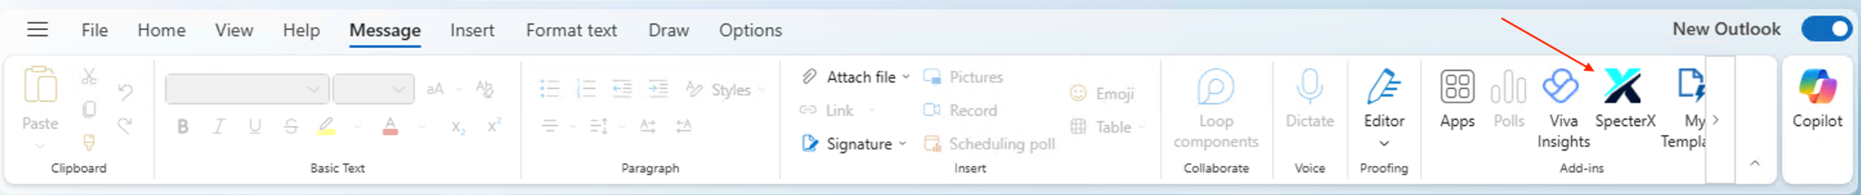
This connector allows you to apply protection to attachments or encrypt email messages, while administrators may enforce rules that adjust policies or block recipients to meet data protection requirements.
The SpecterX Outlook Connector is supported in New Outlook for Windows, Outlook on the Web (Microsoft 365), and New Outlook for Mac. In all supported environments, it appears as an add-in in the Outlook compose ribbon.
To send a protected email:
- Open a new email
- Select the SpecterX add-in from the ribbon
- Apply protection before sending
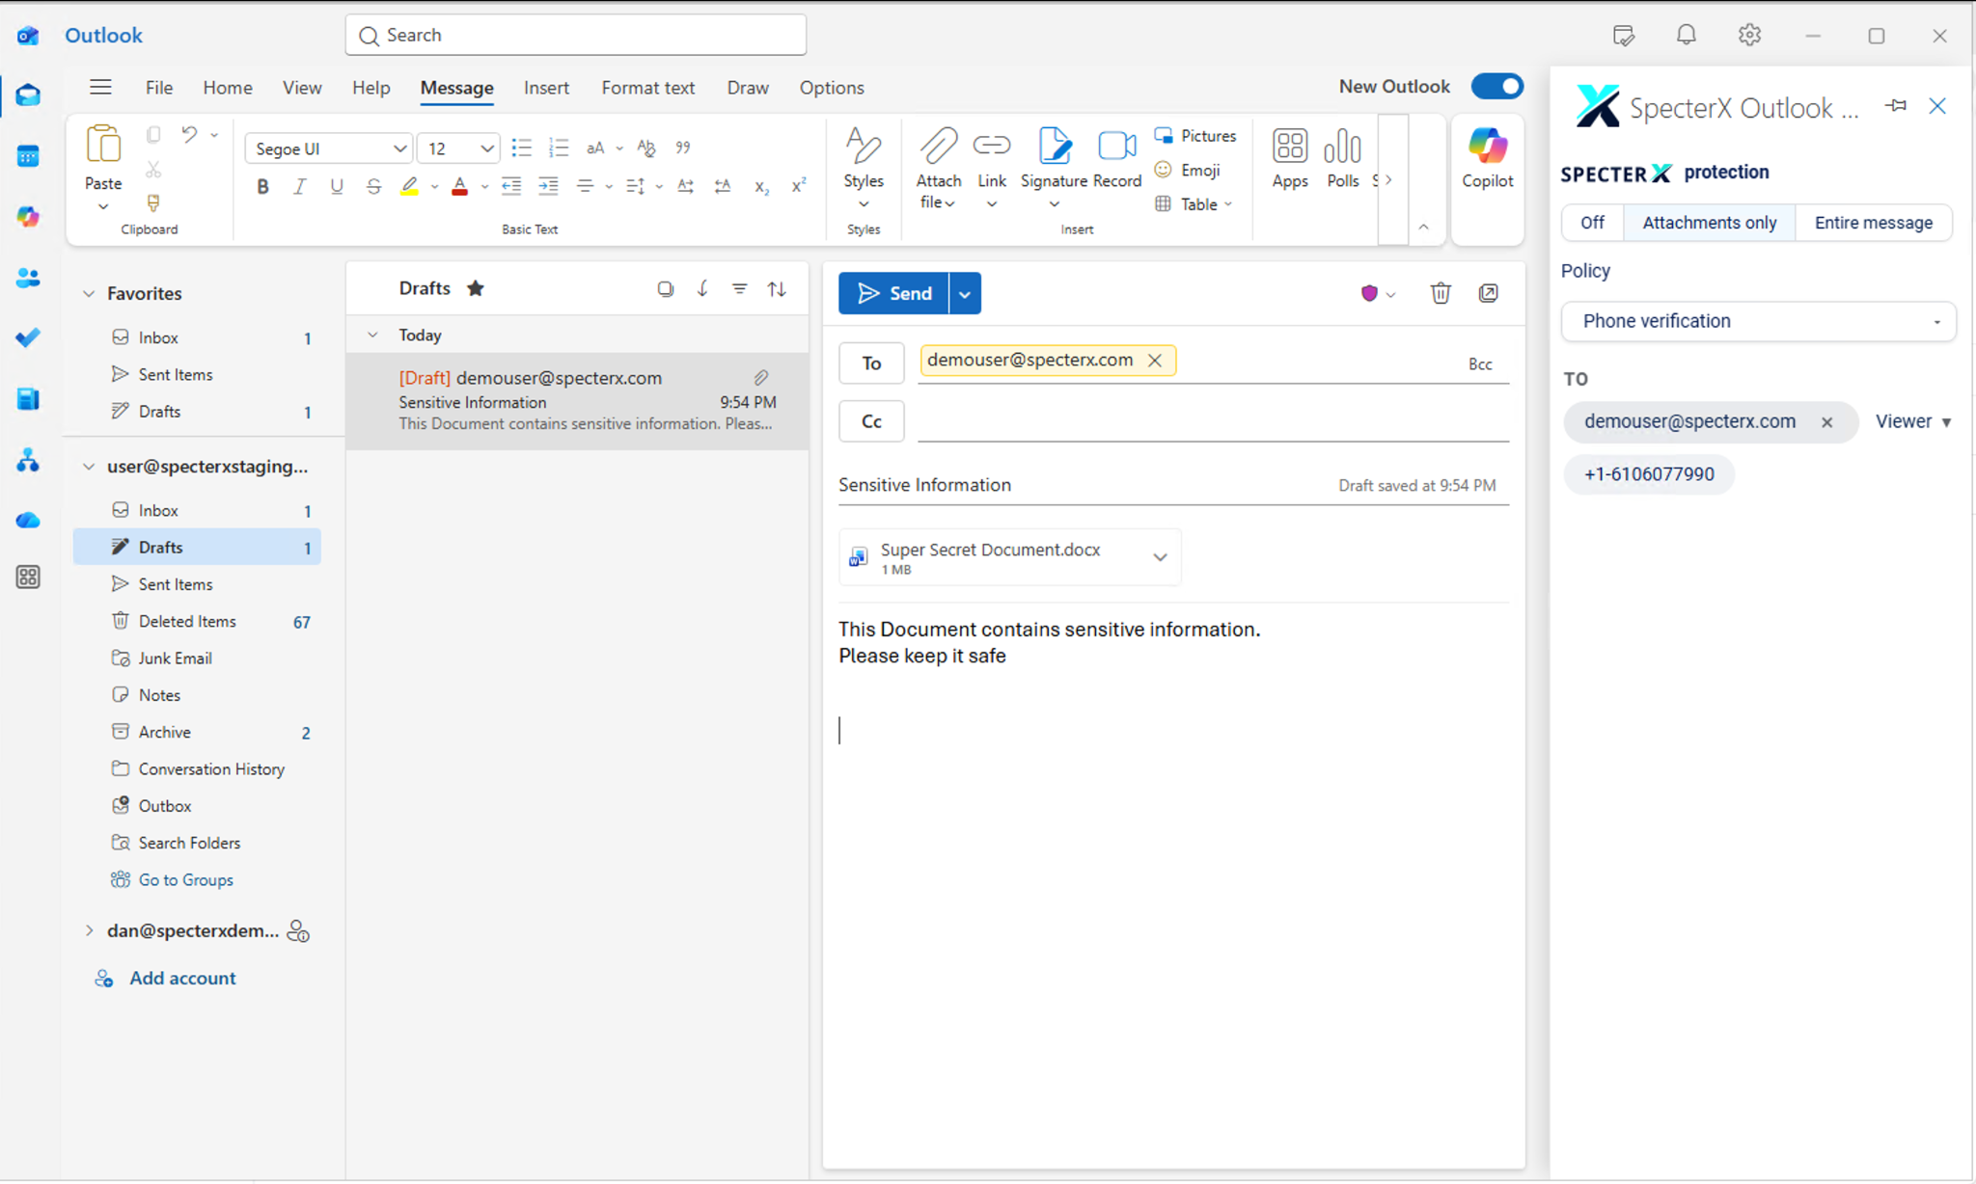
Using SpecterX is built into your normal email flow. You continue to write emails, add recipients, and attach files as usual. The only additional step is selecting a protection policy and configuring any required authentication through the SpecterX panel.
When protection is applied, it applies consistently to all recipients included in the email.

What Happens After Sending
Once sent, the email appears unchanged in your Sent folder. However, attachments are not delivered directly to recipients.
Instead, recipients see a secure SpecterX banner within the email that represents the shared files and provides access based on the applied policy.
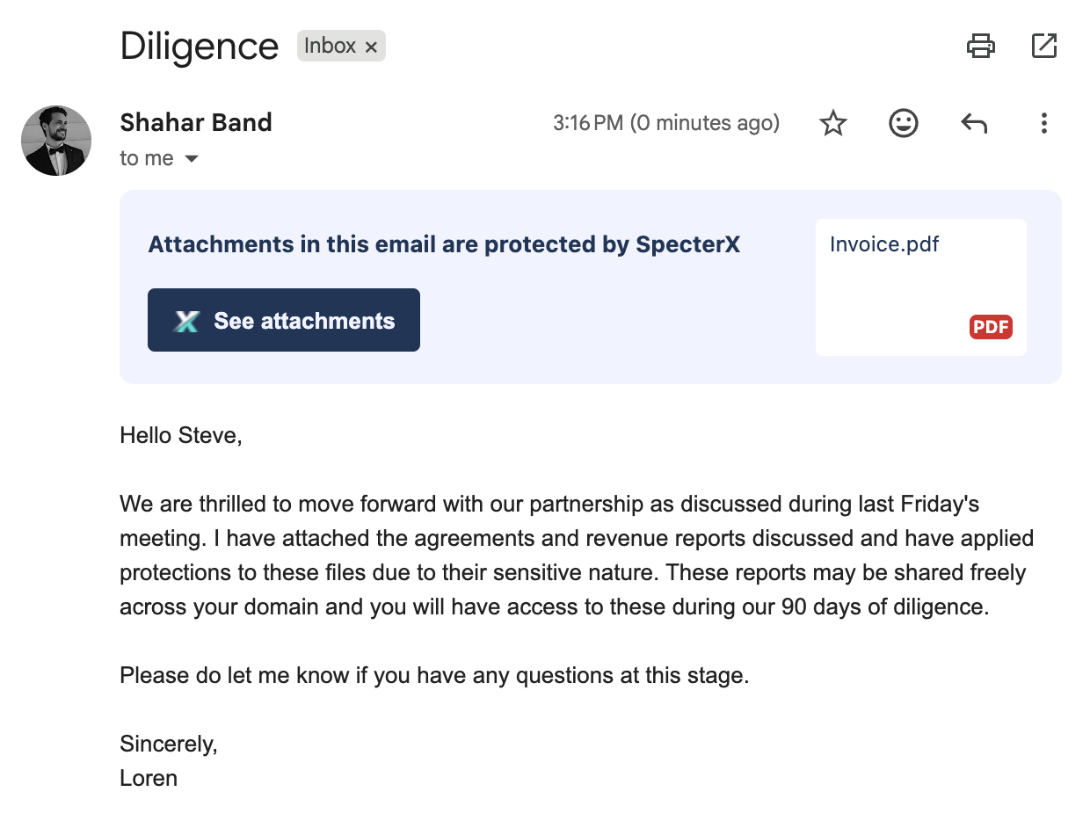
Recipients access files through the secure link, where they may be required to authenticate to validate their access. Based on the applied policy, files are either presented with protections enforced (such as restricted viewing, watermarking, or download controls) or released as unprotected copies after access.
For frequent recipients, authentication may only be required once within a defined session period set by your organization.

Visibility and Control After Sharing
When recipients access files through secure links, you may receive notifications about that activity. If the applied policy includes persistent protection, you can expect real-time updates on access events.
Files remain protected after sharing and can be managed at any time through the SpecterX WebUI. As a data owner, you can view access logs, update policies, or revoke access if needed.

Governance & Automated Enforcement
SpecterX enforces organization-wide governance rules to help protect sensitive data and ensure compliant sharing. These controls, configured by your administrator, may adjust the applied policy or block recipients who are not authorized to access the content.
If a rule impacts your share after sending, you will receive a notification explaining the action taken.
If you need assistance, please contact your administrator or reach out to support@specterx.com.

